Preceptor Guide: Zoll ECG simulator session

Contributor(s): E Krauspe, B Locke, R Sheth, C Long, J Situmeang, A Ryden, S Patel
Last Update: EK 4/29/25

Simulation Resources:
- Companion Power Point Slide Deck (resident facing)

- Zoll ECG Simulator (can plug in directly to Zoll R Series monitor/defibrillator)
  - Options: VT, VT-HI, VT-LO, VF, AFIB, AFLTR, NSR, ASYS, SBrady, 1st AVB, 2nd I AVB, 2nd II AVB, 3rd AVB, TdP, Convert.
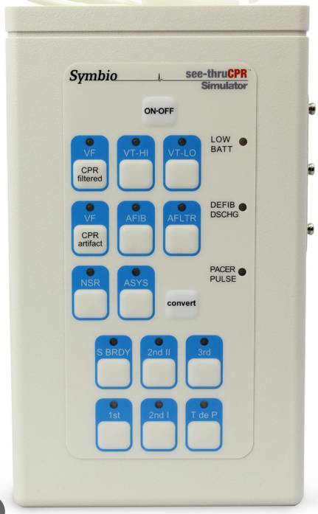
- Zoll R Series Monitor/defibrillator
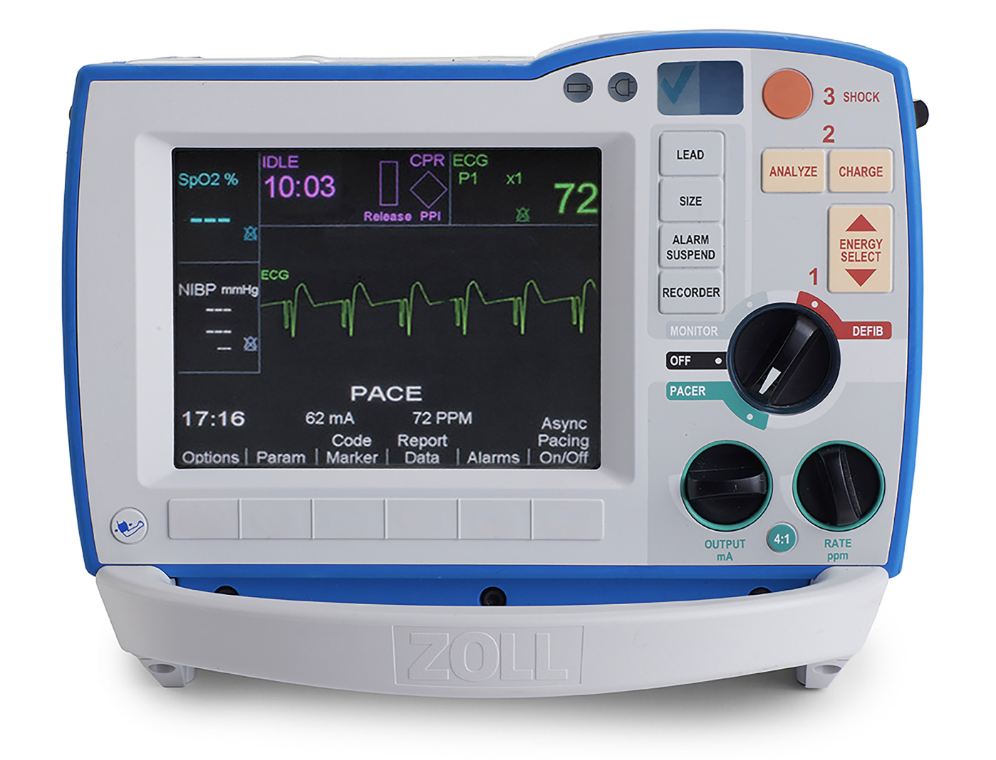

Audience: IM Interns

Duration: 20-30 minutes hands on scenarios

Case List (Clickable)
Case 1: (Asystole) “Can’ Shock What You Can’t See” 1
Case 2: (VF) “Pulseless but Not Powerless” 2
Case 3: (Pulseless VT / VT-HI) “No Pulse, Wide QRS” 3
Case 4: (SVT - PVST/AFL): “ Fast and Faint” 4
Case 5: (3rd Degree AVB): “Slow and Confused” 5
Case 6: (TdP): “Twist and Shout” 5

Case 1: (Asystole) “Can’ Shock What You Can’t See”

Scenario:
- 70M with history of ESRD found unresponsive on the floor. No pulse.
- CPR in progress, IV access obtained.
Initial Zoll Rhythm: Asystole

Management Steps:
- Confirm asystole in >1 lead
- Continue high-quality CPR (2 minutes) then pulse check
  - Consider H/Ts + Labs (ppt slide with resulted labs available)
- Give Epinephrine 1 mg q3–5 min
- Repeat until ROSC or called.
Possible Branch Points:
- If team confirms asystole in 2 leads: Continue CPR + Epi q3–5 min.
- If team does not confirm (and it's fine VF): Opportunity to shock missed → worsening prognosis.
  - Fine VT ppt (slide available, discuss Zoll settings
    - Consider resident role-play how to communicate lab findings quickly to influence ACLS management.
    - General Lab Interpretation
      - Severe metabolic acidosis (low pH, HCO₃⁻), likely from lactic acidosis and hypoperfusion.
      - Hyperkalemia (7.2) → treat urgently
      - Mild hypocalcemia, which may contribute to cardiac instability.
- If hyperkalemia identified and appropriately treated Convert to organized rhythm + absent pulses
- After additional round of ACLS ROSC

Teaching Pearls:
- No shock for asystole
- Review zoll settings & charging
- Review dosing of epinephrine
- Always confirm rhythm isn't fine VF (ppt slide)
- ?Discuss importance of ETCO₂ and reversible causes (e.g., hyperkalemia in ESRD).

Case 2: (VF) “Pulseless but Not Powerless”
Scenario:
- 58F with history of CAD s/p remote DES, CABG now admitted for UTI with sepsis. Telemetry alarms "code blue" on hospital day 2. On initial assessment, pulses are absent.

Initial Zoll Rhythm: VF

Management Steps:
- Immediate CPR
- Charge and shock ASAP (defibrillation)
- Resume CPR
  - Labs available on ppt
- Rhythm check: VF Shock
- Epinephrine q3–5min + Resume CPR
- Rhythm check: VF Shock
- Amiodarone 300 mg IV + Resume CPR
- Continue algorithm until ROSC

Possible Branch Points:
- If team shocks within 2 min: Higher ROSC likelihood.
- If shock delayed >5 min: Worse outcomes, prolonged downtime.
- If Epi then Amiodarone given: VF may organize into a perfusing rhythm.
- If ROSC achieved:
  - Hypotension (SBP 80s) occurs → post-ROSC care (fluids, vasopressors, possible TTM if comatose).
  - EKG Post ROSC available Anterior STEMI discuss next steps
- If team fails to reassess rhythm every 2 min: Missed VF → PEA ensues.

Teaching Pearls:
- Time to first shock is critical in VF
- Emphasize compression quality, minimizing pauses and rhythm checks every 2 minutes.
- Role of antiarrhythmics is adjunctive, not primary
- Quick Prioritization in Practice:
  - Think acute MI, electrolyte derangements, and hypoxia first in the setting of sudden VF arrest.
  - In peri-arrest or monitored settings (e.g., during a procedure), drug toxicity or iatrogenic causes may be more likely.

Case 3: (Pulseless VT / VT-HI) “No Pulse, Wide QRS”
Scenario:
- 45M with HFrEF collapses in clinic waiting room. Code is called. Initial assessment reveals absent pulses.

Initial Zoll Rhythm: Pulseless VT (VT-HI)

Management Steps:
- Begin CPR
- Immediate defibrillation
  - Consider prompting a scenario where pads are not placed (or placed incorrectly)
- Epinephrine + Amiodarone per ACLS
- Reassess after each 2 min cycle

Possible Branch Points:
- Immediate defibrillation given: VT-HI → NSR achieved.
- If CPR + Epi continue but defibrillation missed: Rhythm degenerates to asystole.
- If Amiodarone given after 3 shocks: Organized wide complex rhythm with ROSC.
  - Post ROSC EKG on PPT deck Monomorphic VT, HDS
- If ROSC achieved but wide QRS remains: Need to address underlying cause (ischemia, electrolyte imbalance).
- If no ROSC after 20 min despite ACLS: Family meeting and consider terminating resuscitation efforts.

Teaching Pearls:
- Don't delay shock for rhythm clarification if no pulse.
- Contrast pulseless VT vs stable VT
- Discuss defibrillator pad placement and safety.

Case 4: (SVT - PVST/AFL): “ Fast and Faint”

Scenario:
- 36F admitted for ETOH detox. RRT activated on third day of admission. Tachycardic, HR 180s, dizzy/lightheaded but responsive, pulsatile in all ext.

Initial Zoll Rhythm: SVT (PSVT vs AFlutter)

Management Steps:
- Assess for stability (hypotension, AMS, CP?)
- If unstable → synchronized cardioversion
- If stable (provide EKG on PPT) → vagal maneuvers, then Adenosine 6 mg
- Reassess rhythm (may convert or reveal underlying flutter)

Possible Branch Points:
- If vagal maneuvers successful: Converts to NSR. Patient asymptomatic. Etiology PSVT
- If vagal fails and Adenosine 6 mg given rapidly: PSVT terminates but underlying atrial flutter with 2:1 block uncovered (rate 150).
  - See EKG #2 on PPT
  - Tx options: BB/CCB +/- Cardioversion (expert consultation)
- If unstable (SBP <90, AMS, CP) develops: Urgent synchronized cardioversion needed (50–100J biphasic).
- If team misidentifies and delays cardioversion: Decompensation → code blue called.

Teaching Pearls:
- Review bedside vagal maneuvers.
- SVT vs sinus tach vs AFlutter at 2:1 block.
- Pharmacotherapy options for SVT

Case 5: (3rd Degree AVB): “Slow and Confused”
Scenario:
- 82F with bradycardia, confusion, SBP 80s. Monitor shows complete heart block.

Initial Zoll Rhythm: CHB
- EKG available on your arrival slide deck (Complete AV dissociation, HR 30s on EKG)

Management Steps:

- Atropine 0.5mg bolus. Repeat q3-5min (max 3mg)
- Transcutaneous pacing immediately
- Escalation + expert consultation: prepare for transvenous pacing
- Consider epinephrine or dopamine infusion

Possible Branch Points:
- If transcutaneous pacing started early: Capture achieved → BP improves.
- If pacing delayed: SBP drops further, LOC worsens, cardiac arrest risk.
- If Atropine 0.5 mg tried: No improvement (because block is infranodal). Team learns atropine is unreliable here.
- If transvenous pacer not available: Start Epinephrine drip (2–10 mcg/min) while awaiting higher-level intervention.
- If capture maintained: Patient stabilizes, consult cardiology for PPM.

Teaching Pearls:
- Complete heart block = AV dissociation.
- Atropine ineffective in infranodal blocks.
- Always have pacing pads in place during rapid responses.
  - Review transcutaneous pacing settings on Zoll

Case 6: (TdP): “Twist and Shout”

Scenario:
- 24F with recent QT-prolonging meds collapses on telemetry. Monitor shows polymorphic VT.

Rhythm: Torsades de Pointes (TdP)
Management Steps:
- Pulseless Arrest Algorithm
- Pulse+ Tachycardia with Pulse Algorithm
- Defibrillation (if pulseless)
- Can consider IV Magnesium 2 g over 10–15 minutes
- Discontinue QT-prolonging meds on stabilization

Possible Branch Points:
- If pulseless: Immediate unsynchronized shock.
- If pulses present but unstable: Immediate synchronized cardioversion preferred.
- If Magnesium 2g IV given promptly: TdP resolves, underlying QTc prolongation seen.
- If magnesium delayed: consider degeneration to VF → code escalation.
- If QT-prolonging agent (e.g., methadone, ziprasidone) identified and stopped: Risk of recurrence reduced.
- If prolonged bradycardia remains: Overdrive pacing (temporary pacing at HR ~90) considered.

Teaching Pearls:
- Magnesium even if Mg level is normal.
- Common reversible causes (meds, hypokalemia).
- Distinguish from monomorphic VT.

